Model Tuning and Output

We split the training data randomly by .2 make a validation data set because the validation set only had 16 observations.

The proportions are about the same between the training, validation, and testing data between the Normal and Pneumonia. The proportions are specified below with the amount of proportion with respect to Pneumonia.

train_ratio (# of pneumonia images/# of x-ray images in train data) = 0.65625

val_ratio (# of pneumonia images/# of x-ray images in val data) = 0.75

test_ratio (# of pneumonia images/# of x-ray images in test data) = 0.6875

This report contains 11 iterations with specific parameter values, and the resulting training, validation, and test metrics.

1.Shows 25 examples of test data. Below. 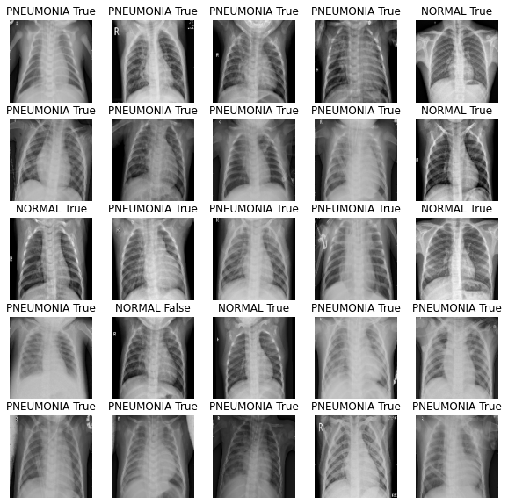The labels above the images are the predicted labels. The true label can be easily deduced from the fact that we are only working with two classes Pneumonia and Normal for each x-ray image. We labeled to the right of the prediction a Boolean if we predicted correctly a True is shown and if not a False is shown and the true label is the label not specified above the image.

The best iterations I found on the test dataset were iterations 8 with a test acc of 90.2% and 11 with a test acc of 90.5%. Iteration 8 has a better-looking graph of training and validation that iteration 11, because it used a smaller learning rate. Therefore, 11 may have a better test acc than 8, but it may not be the best model on other test data sets. Further testing is required to find the best model to correctly classify x-rays of chests as Normal or chests that have Pneumonia.

|  |  |  |  |  |
| --- | --- | --- | --- | --- |
| Part2&3  Iteration | Parameters | Dense layers and amount of layers fine tuned | Results (Accuracy) | Plot |
| 1 | Epochs = 7  Fine tune at = 100  Lr = 0.0001  Activation = “Relu”  Total params: 3,913,729  Trainable params: 3,517,185  Non-trainable params: 396,544 | Start w/ repeated Conv2d # of filters per layer is (128,64) filter size (3,3 )and MaxPooling2d filter (2,2), end w/ Dense layers used  (512, 128, 64) w/ Dropout(0.5)  Fine tuned 54 layers of Convnet | Train % = 90.1  Validation % = 92.2  Test % = 81.0 |  |
| 2 (less epochs) | Epochs = 3  Fine tune at = 100  Lr = 0.0001  (only change from 1st iteration)  Activation = “Relu”  Total params: 3,913,729  Trainable params: 3,517,185  Non-trainable params: 396,544 | Same as above, with fewer epochs  Observed noticeable decrease in train, validation, and test % accuracy values | Train % = 85.1  Validation % = 87.3  Test % = 68.8 |  |
| 3 | Epochs = 25  Fine tune at  = 100  Lr = 0.0001  Activation = “Relu”  Total params: 3,088,449  Trainable params: 2,691,905  Non-trainable params: 396,544 | Dense layers used (512,256,128,  64, 32) and dropout(0.5)  Fine tuned 54 layers of Convnet | Train % = 92.4  Validation % = 92.7  Test % = 88.7 |  |
| 4 | Epochs = 15  Fine tune at  = 109  Lr = 0.0001  Activation = “Relu”  Total params: 3,088,449  Trainable params: 2,573,633  Non-trainable params: 514,816 | Dense layers used  (512,256,128,  64, 32) and dropout(0.5)  Fine tuned 45 layers of Convnet | Train % = 93.8  Validation % = 94.1  Test % = 88.1 |  |
| 5 | Epochs = 20  Fine tune at  = 136  Lr = 0.0001  Activation = “Relu”  Total params: 3,088,449  Trainable params: 1,881,025  Non-trainable params: 1,207,424 | Dense layers used (512,256,128,  64, 32) and dropout(0.5)  Fine tuned 18 layers of Convnet | Train % = 91.0  Validation % = 91.4  Test % = 86.0 |  |
| 6 | Epochs = 10  Fine tune at  = 109  Lr = 0.0001  Activation = “Relu”  Total params: 2,983,681  Trainable params: 2,468,865  Non-trainable params: 514,816 | Dense layers used (512,128  ,32) and dropout(0.5)  Fine tuned 45 layers of Convnet | Train % = 92.1  Validation % = 92.1  Test % = 87.5 |  |
| 7 | Epochs = 10  Fine tune at  = 100  Lr = 0.0001  Activation = “Relu”  Total params: 3,088,961  Trainable params: 2,692,417  Non-trainable params: 396,544 | Dense layers used (512,256,128,  64, 32,16) and dropout(0.5)  Fine tuned 54 layers of Convnet | Train % = 92.8  Validation % = 92.8  Test % = 86.1 |  |
| 8 | Epochs = 30  Fine tune at  = 109  Lr = 0.0001  Activation = “Relu”  Total params: 3,061,697  Trainable params: 2,546,881  Non-trainable params: 514,816 | Dense layers used (512,256,  64) and dropout(0.5)  Fine tuned 45 layers of Convnet | Train % = 94.8  Validation % = 94.4  Test % = 90.2 |  |
| 9 | Epochs = 60  Fine tune at  = 109  Lr = 0.00001  Activation = “Relu  Total params: 3,061,697  Trainable params: 2,546,881  Non-trainable params: 514,816 | Dense layers used (512,256,  64) and dropout(0.5)  Fine tuned 45 layers of Convnet | Train % = 89.1  Validation % = 90.5  Test % = 89.4 |  |
| 10 | Epochs = 30  Fine tune at  = 109  Lr = 0.00001  Activation = “Relu  Total params: 3,061,697  Trainable params: 2,546,881  Non-trainable params: 514,816 | Dense layers used (512,256,  64) and dropout(0.5)  Fine tuned 45 layers of Convnet | Train % = 90.2  Validation % = 91.2  Test % = 81.4 |  |
| 11 | Epochs = 15  Fine tune at  = 109  Lr = 0.001  Activation = “Relu  Total params: 3,061,697  Trainable params: 2,546,881  Non-trainable params: 514,816 | Dense layers used (512,256,  64) and dropout(0.5)  Fine tuned 45 layers of Convnet | Train % = 93.4  Validation % = 93.0  Test % = 90.5 |  |